**Game Design  
Document – One Pager  
Blast and Solve**

**[Game Image]**

**Description**

A strategy game that requires you to make a chain reaction between bombs, on which you can attach different explosions, shape of the explosion, and even adjust the range of impact and the explosion itself. The goal is to clear all the required rubbles in the given time after lighting up the first bomb.

**Core Loop**

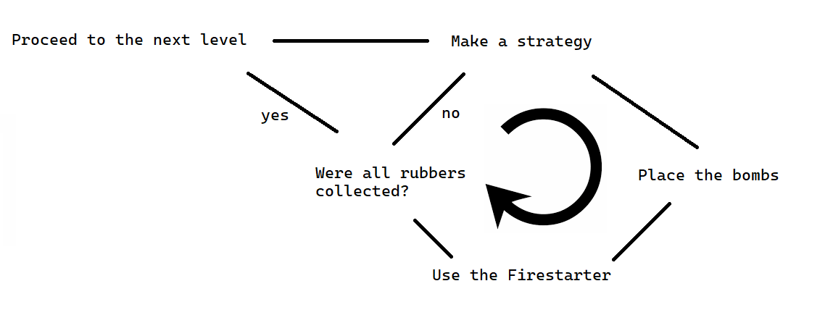

**Kind of Fun**

* Strategy – making a strategy that depends on what kind of items does the user have and limited movements is the main kind of fun in the game.
* Levels – every level should be in a way different that the rest, so it should trigger some curiosity in the player and challenge him in a more advanced level.
* Animations – different animation should help the player adapt into the game and satisfy their liking.

**Genre – 3D, Strategy, Single Player, Puzzle**

**Theme – Arcade, Classic**

**Boundaries & Setting:**

* The player can only interact with his items, placing them on the field, also removing, rotating, and attaching other items to them.
* The “Unbreakable Wall” can be destroyed by combining both ice bomb to freeze it and sonic waves to break it.
* The “Breakable Wall” can be destroyed by using only the sonic waves.
* The “Ice Wall” can be melted by the “Fire Bomb”.
* The “Death Block” instantly loses the player’s level if an explosion has reached him.
* The “River Block” becomes an “Ice Wall” if used the “Ice Bomb”.
* To complete the level, the player needs to get all the “Rubble Blocks”.
* There are “Special Rubble Blocks”, which when cleared, add more time.
* The timer in “Timer Bomb” can be adjusted.
* The teleportation of the “Teleportation Bomb” works withing some range.
* The “Bounce Bomb” bounces only ones up to adjusted range.
* Cannot be attached more than one of the same types of adjustment to a single bomb (Shape, Explosion, Range).
* If the timer runs out and not all the required rubbles were cleared, the player loses the level.

